Devin Hardy

00076619

CS423

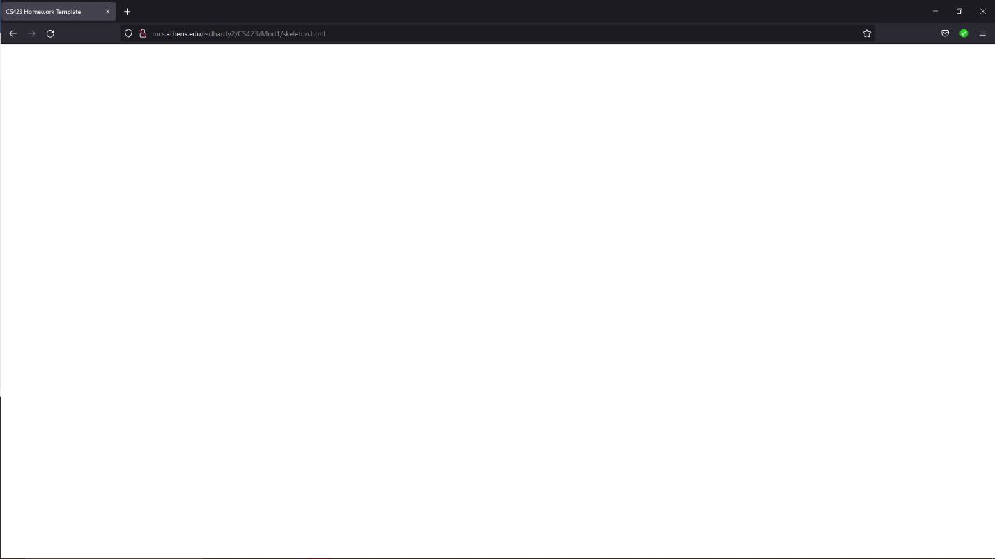

<!DOCTYPE html>

<HTML>

<HEAD>

<TITLE>CS423 Homework Template</TITLE>

<SCRIPT

TYPE="text/javascript"

SRC="../libs/three.js">

</SCRIPT>

<STYLE>

body {

margin: 0;

overflow: hidden;

}

</STYLE>

</HEAD>

<BODY>

<DIV ID="WebGL-output">

</DIV>

<!-- Scripts that we use for running things -->

<SCRIPT TYPE="text/javascript">

// Put the bulk of what we do in the onlad handler

// for the window.

funcion init() {

// Put Three.js stuff here.

}

window.onload = init

</SCRIPT>

</BODY>

</HTML>